

SIMATS ENGINEERING

Saveetha Institute of Medical and Technical Sciences
Chennai- 602105

Student Name: Kaviya.G Reg. No.: 192524281
Course Code: CSA0851 Slot: D
Course Name: Python programming for Healthcare
Course Faculty: Dr.G.Ayyappan and Dr.U.Arul
Project title: LEARNING PROFILE GENERATOR WITH LOGIC AND FILE WRITING
Module Photographs:
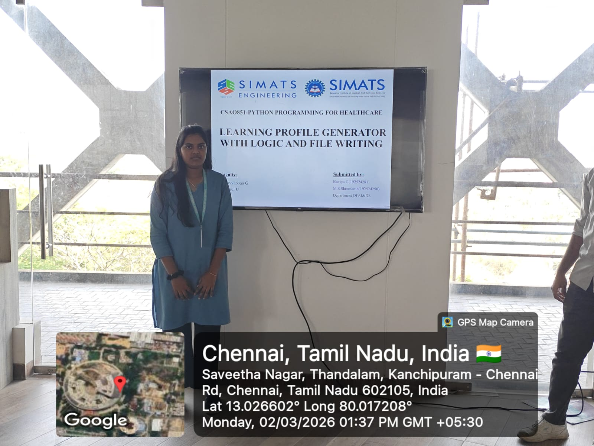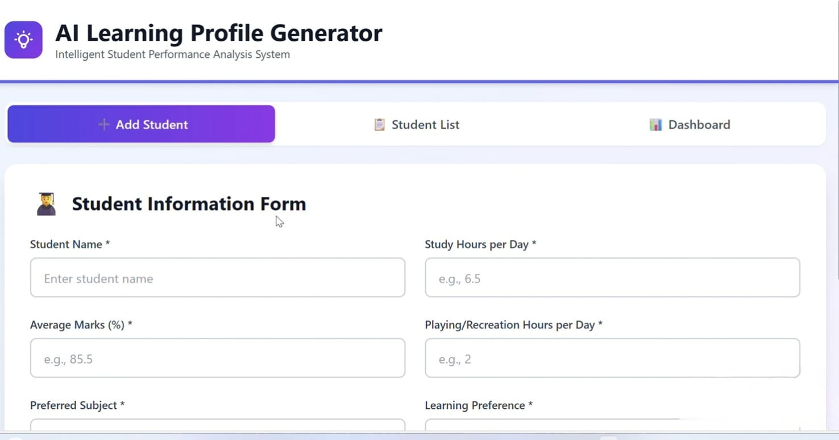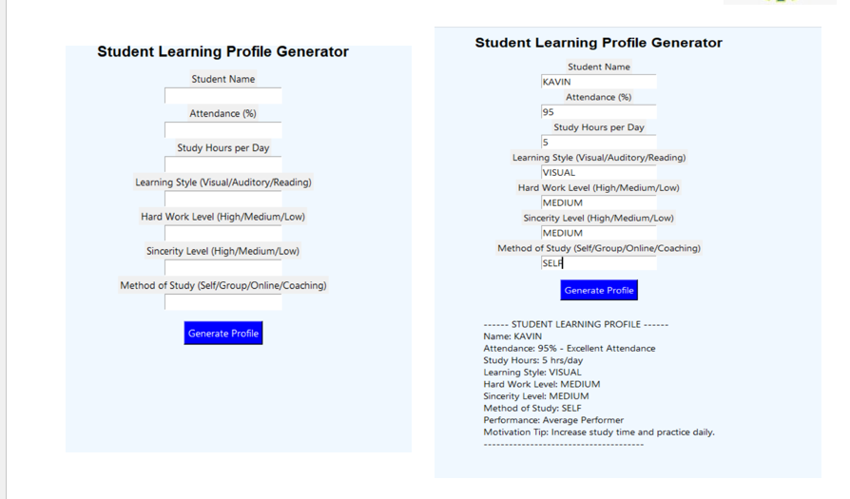
Project Description:
The Learning Profile Generator with Logic and File Writing is a Python-based application designed to analyze student data and automatically generate personalized learning profiles. The main objective of this project is to help educators understand students’ academic behavior and performance patterns using logical decision-making and file handling techniques.The system collects essential inputs such as student name, attendance percentage, study hours per week, preferred learning style (visual, auditory, reading/writing, or kinesthetic), sincerity level, and study method. Based on these parameters, conditional logic is applied to evaluate the student’s learning category. For example, students with high attendance and consistent study hours may be classified as “Consistent Performers,” while those with irregular study patterns may be identified as “Needs Guidance.” The classification is done using structured if-else decision logic to ensure accurate and meaningful output.File writing plays a crucial role in this project. After generating the profile, the system stores the student’s data and evaluation results in a text file or database file. This ensures permanent record maintenance, enabling future retrieval, analysis, and comparison. The use of file handling concepts such as open(), write(), and close() demonstrates practical implementation of persistent data storage.. The system can be further enhanced by adding graphical user interfaces (GUI), database connectivity, or data visualization features.Overall, the Learning Profile Generator is a simple yet effective educational support tool that demonstrates how programming logic and file management can be applied to solve real-world academic monitoring problems efficiently.

Student Signature Guide Signature

